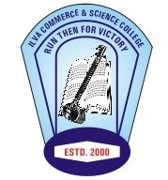 Prabhodit
E-News letter Commerce and Science College
( Managed by Shri Indore Loha Vyapari Parmarthik Trust)
Vol: 02 Jan-June 2016
Editor –Dr. Viveka Dubey
Welcome to the second edition of the e-newsletter. Prabhodit. It gives us immense pleasure to present our this issue of Prabhodit. The response you all gave is very encouraging and positive. In the second session we had various activities including the annual function-Spectrum, N.S.S camp, sports week, inauguration of renovated Computer lab and Library.

- The teachers got their research paper published in National and International journals and participated in workshop and seminar.
- The seven days N.S.S camp was organised in Mhow. The students participated with great excitement and zeal. Health camp of Rotary club in Betma was assisted by the N.S.S team. The students volunteered during Prime Minister Shri Narendra Modi’s visit to Mhow on Ambedkar Jayanti.
- The most awaited is the annual function of the college. This year the annual function Spectrum was celebrated on March 4th 2016 at Ravindra Natya Griha along with lunch for staff and participants and dinner for the invitees and students. The chief guest was veteran advocate and ex Advocate General Shri Anand Mohan Mathur.(see pictures)
- The renovated Library and Computer Lab was inaugurated on March 22nd 2016.(see pictures)
- Felicitation of the newly appointed Vice- Chancellor Shri Narendra Dhakad was done, Trust Chairman, Secretary, Treasurer, Association Vice President, College Chairman, Secretary, Joint Secretary and college Education Board were present. (see pictures)
- The mission of the college EEE-Education Ethics Empowerment now accompanies the message of * Save Water*Save Tree *Save Energy.
- Admission counselling has started and online admission process is followed. The enquiry brochure and admission brochure gives the message of * Save Water*Save Tree *Save Energy.
- World Environment Day was celebrated .The college bag with the message of *Save Water*Save Tree *Save Energy were distributed to the students.(see picture)

Jewels in the Crown:
In House Competitions:
Activities | I Position | II Position
Salad Decoration:

Poster Making:

Mehndi :

Rangoli :

Outstanding Cultural Performance:
Ram Ingle
Amit Kale
Mahesh Bagzai

Never stop learning, because life never stops teaching- Unknown
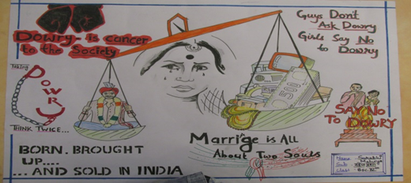
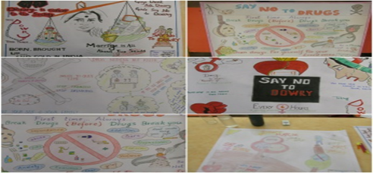
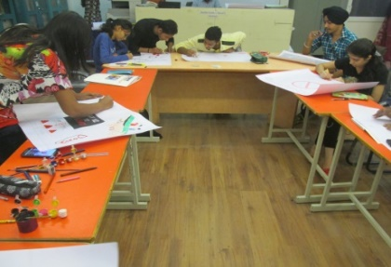
In-House Activities:-
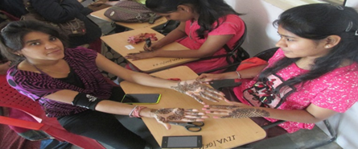
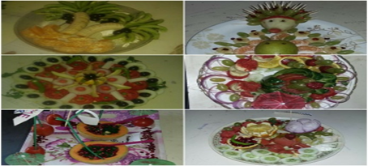
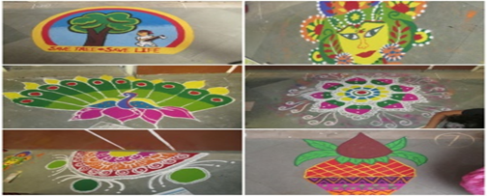
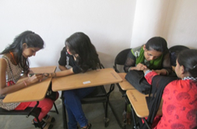

All power is within you; you can do anything and everything-Swami Vivekanand

Spectrum: Annual Function 2015-16
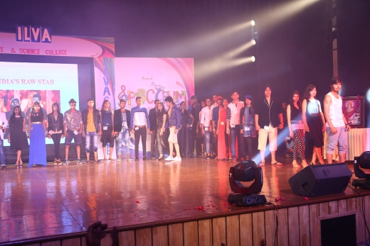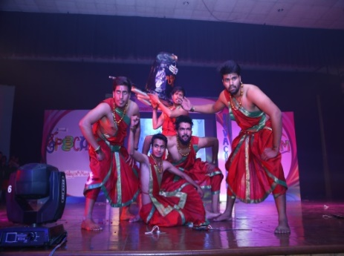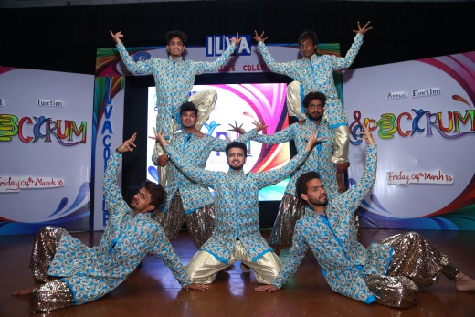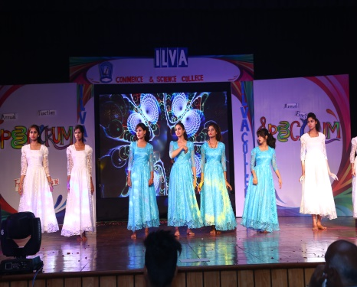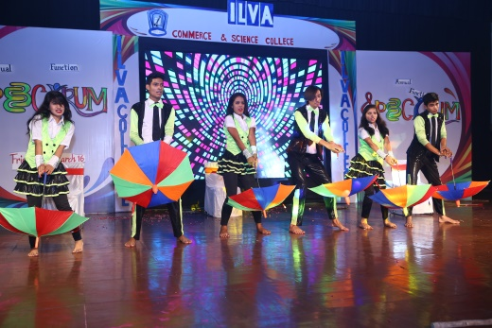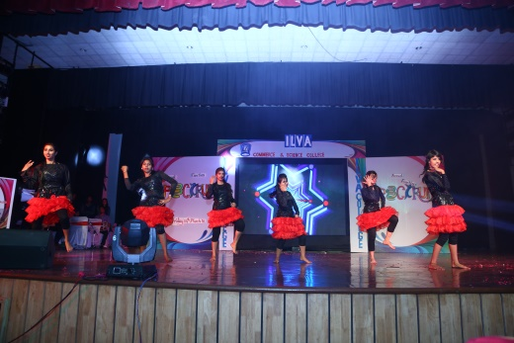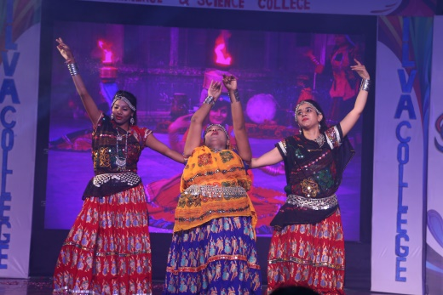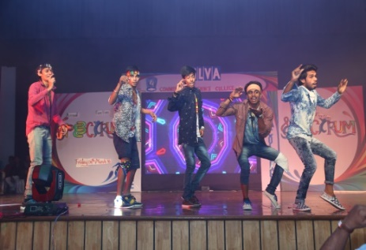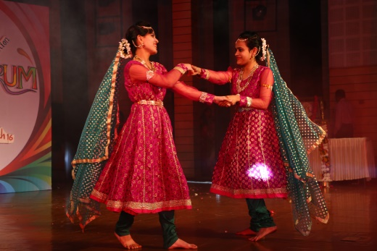

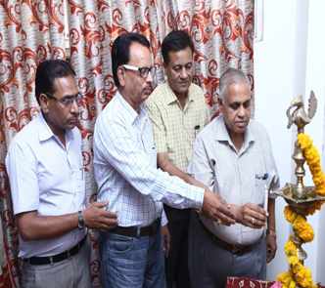
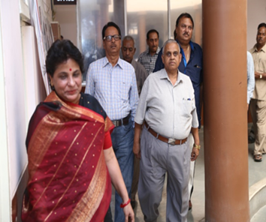
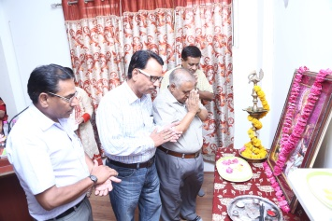
Felicitation of the newly elected Vice Chancellor:
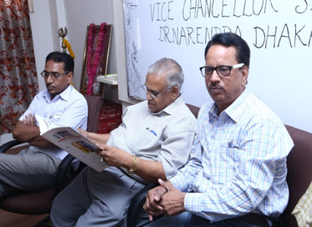
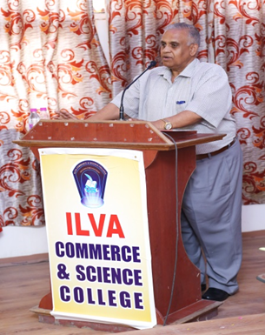

Life is beautiful combination of body and soul gifted to us by the almighty-Unknown

National Service Scheme (N.S.S): Seven days camp at Mhow:
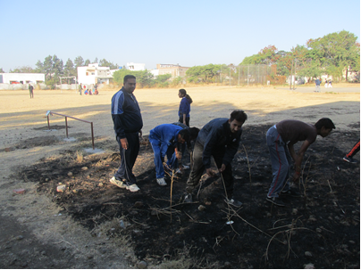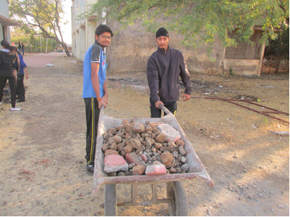
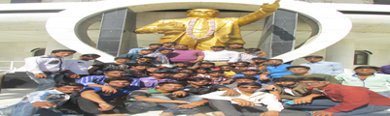

Admission Counselling:

